**Chapter3 -SAMBA (PDC)**

**What is Samba ?**

Samba is an Open Source/Free Software suite that provides seamless file and print services to SMB/CIFS clients. Samba is freely available, unlike other SMB/CIFS implementations, and allows for interoperability between Linux/Unix servers and Windows-based clients.

Configuration :-

**Creating Anonymous share**

**Step 1 »** Install samba packages after updating repositories

# apt-get update

# sudo apt-get install samba samba-common python-glade2

**Step2 »** Create folder for Anonymous s hare.  
# sudo mkdir -p /shares/anonymous

**Step 3 »** Change the ownership to nobody so that everyone can access and store files in that folder.  
# sudo chown nobody:nogroup /shares/anonymous/

**Step 4 »** Now define values in samba configuration to share **/shares/anonymous/** folder. **/etc/samba/smb.conf** is the main configurion file for samba .Take a backup before editing that file.  
# sudo cp /etc/samba/smb.conf /etc/samba/smb.conf.org

now add the below code at the end of the file to enable share.  
# sudo vim /etc/samba/smb.conf

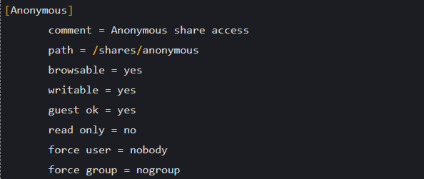

**Step 5 »** Now restart smbd service .  
# sudo service smbd restart

## Creating secured share

## Secured shares can be accessed using username and password .Here for example, I’m going to create share project1.

## Step 6 » Create a folder for share .

## # sudo mkdir -p /shares/project1

## Step 7 » Create a new group smbproj1,so that Users added to this group can access project1 share.

## # sudo addgroup smbproj1

## Step 8 » Modify ownership and permission for the folder.

## # sudo chown root:smbproj1 /shares/project1/

## # sudo chmod 770 /shares/project1/

## Step 9 » Now define values in the configuration file .

## # sudo vim /etc/samba/smb.conf

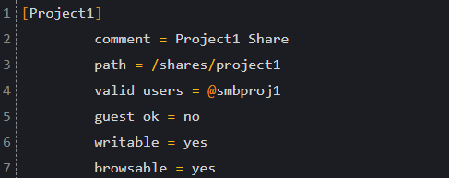

**Step 10 »** Now restart smbd service .

# sudo service smbd restart

After restarting service, you could see **Project1** share . Additional secured shares can be created in the same way.

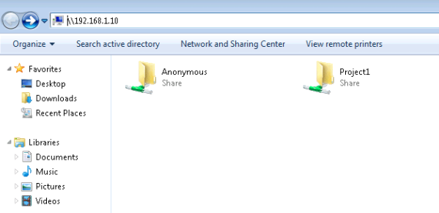

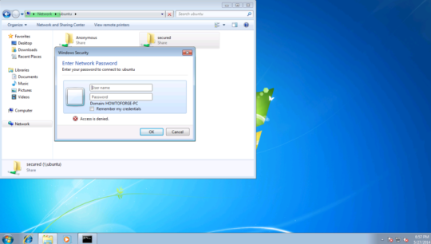

**User creation**

Add new user john for accessing **project1** share

**Step 11 »** Create a user **john** .

# sudo useradd john -s /usr/sbin/nologin -G smbproj1

**-s /usr/sbin/nologin** : Restricting shell access  
**-G smbproj1** : Added to smbproj1 group

**Step 12 »** Create samba password for user john  
# sudo smbpasswd -a john

Now user john can access **Project1** share. Additional users can be added in the same way.  
For existing users use **usermod** command to add user in smbproj1 group and create samba password using smbpasswd.

# sudo usermod mike -G smbproj1

For accessing multiple shares. Example: dave has access to multiple project groups like smbproj1 and smbproj2.

# sudo usermod dave -G smbproj1,smbproj2

**Change Samba password via Terminal**

pwchange@V220:~$ smbpasswd -U user1

Old SMB password:

New SMB password:

Retype new SMB password:

Password changed for user user1